Bio-sketch of key speakers:
Dr. Roberto Tomasi
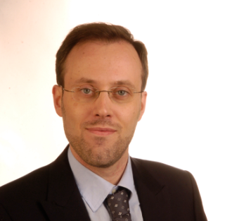
- Dr. Tomasi is a faculty member of the Department of Civil, Environmental and Mechanical Engineering of University of Trento, Italy, and is currently a Harrison McCain Visiting Professor at UNB. He is co-author of more than 40 papers published in peer reviewed journals and conference proceedings, and of a manual on Timber Engineering. His current and recent research activity includes the ductile design of timber joints, glued-in rods, analysis of the interaction between timber floor and masonry, and seismic behavior of multi-storey timber buildings. Dr. Tomasi is active in outreach program at Trento and an instructor of professional courses, and as coordinator of a Help Desk Website specifically directed to timber design professionals (http://risponde.promolegno.com/).

